Note on selection of critical layer of soil liquefaction
Yan-Guo Zhou*, Yue Wang
MOE Key Laboratory of Soft Soils and Geoenvironmental Engineering, Institute of Geotechnical Engineering, Center for Hypergravity Experimental and Interdisciplinary Research, Zhejiang University, Hangzhou 310058, P. R. China. *E-mail: qzking@zju.edu.cn
March 25, 2019
According to previous study (e.g., Moss 2003; Cetin et al. 2004; Kayen et al., 2013), the following guidelines for the selection of critical layer of liquefaction are recommended.
Critical layer selection is a vital step in estimating the seismic strength of a particular soil deposit, of which the criteria is finding the stratum of soil that is the weakest-link-in-the-chain from a liquefaction perspective.
- As for CPT testing
Finding the weakest link requires observing the tip resistance and friction ratio of CPT testing in conjunction, with the addition of a SPT log, for soil classification, if one is available. For most depositional environments this can be a simple matter of looking for the smallest continuous stretch of tip resistance with low friction ratio that agrees with the SPT log in terms of a liquefiable material.
The CPT data of Xi Dai Fu Tou (Zhou and Zhang, 1978), located in the area of Tangshan, China, is selected as an example to illustrate the methodology adopted for estimating the critical layer for a typical liquefaction case history. As shown in Figure 1, there is the lowest friction ratio of a liquefiable stratum at depths ranging from 4.5m to 5.5m, so we can select this medium sand layer as critical layer.
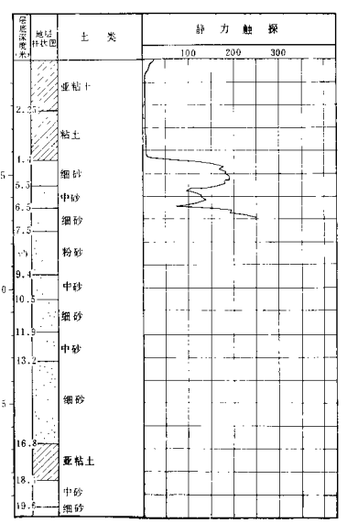
Figure 1. Exploration data of Borehole located in Xi Da Fu Tou, Tangshan
(Zhou and Zhang, 1978)
- As for SPT testing
Based on available data (gradation curves of the sand boil material and the potentially liquefiable soil layers, SPT blow-counts, finest content, site response analysis results, and other geological and geotechnical factors) estimate the layer or the sub-layer that is potentially critical layer.
The SPT data of Oil tank site BA-2 (Ishihara et al., 1980), located in the area of Ishinomaki fishery port, Japan, is selected as an example to illustrate the methodology adopted for estimating critical layer for a typical liquefaction case history. As shown in Figure 2, the site is underlain by fine to medium sandy layers which are loose.
Based on site investigations and the results of cyclic triaxial test performed on “undisturbed” (frozen) samples obtained at various depths, it was concluded that the liquefied layer is the loose fine sand layer at depths ranging from 1.4 to 6 meters. At the same time, the SPT blow-counts in potentially critical layer is very small (Cetin, 2000)
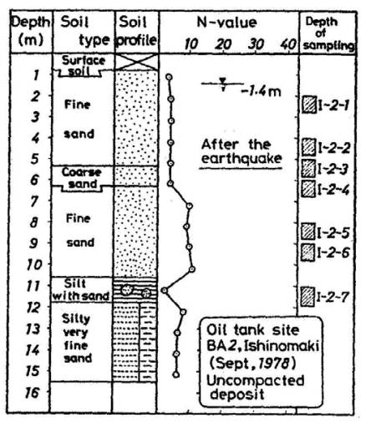
Figure 2 Standard penetration resistance and depths of sampling at the uncompacted site after the earthquake (Ishihara et al., 1980)
- As for Vs
When compiling a field database of case history using Vs data, we should identify the critical layers should meet the following requirements: i) the stratum is liquefiable and restricted below the ground water table, which can be judged from soil boring and soil classification via laboratory tests; ii) the stratum shows property with the lowest normalized shear wave velocity (V_{s1}) (Kayen et al, 2013), meanwhile the chosen stratum should be as shadow as possible. When the penetration logs are unavailable, we can select the most liquefiable layer from the zone of minimum V_{s1} that are comprised of Zone A soil whose plasticity index (PI)＜12 and liquid limit (LL)＜37 (Kayen et al, 2013).
As shown in Figure 3, in the loose gravel layer, there are low shear wave velocities in depth ranging from 4.9m to 7.0m, so we select this strata as potentially critical layer.
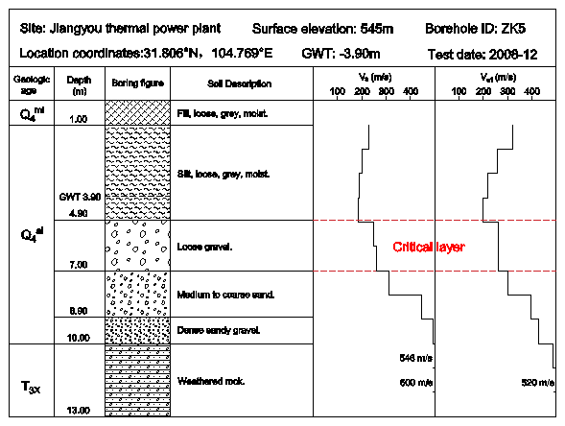
Figure 3. Shear wave velocity profiles for Jiangyou thermal power plant,Sichuan

References:
[1] Kayen, R., Moss, R. E. S., Thompson, E. M., Seed, R. B., Cetin, K. O., & Kiureghian, A. D., et al. (2013). Shear-Wave Velocity–Based Probabilistic and Deterministic Assessment of Seismic Soil Liquefaction Potential. Journal of Geotechnical and Geoenvironmental Engineering.
[2] Cetin, K. O., Seed, R. B., Der Kiureghian, A., Tokimatsu, K., Harder Jr, L. F., Kayen, R. E., & Moss, R. E. (2004). Standard penetration test-based probabilistic and deterministic assessment of seismic soil liquefaction potential. Journal of geotechnical and geoenvironmental engineering, 130(12), 1314-1340.
[3] Moss, R. E. (2003). CPT-Based Probabilistic Assessment of Seismic Soil Liquefaction Initiation. Dissertation.

